Problem set 3
1) Normally options that have the highest potential gains are more actively traded options by the investors. An ‘at-the-money-option,’ gets the highest ‘time premium,’ and thus has the highest potential for gain.
2) As per the given problem the following are the assumptions that have been taken to know the actual breakeven of a call.Value of the call if the spot price on the expiry date is in the range $36.5 to 52.5 with intervals of $4
Situation | Exercise Price | Spot Price | Action | Call Price | Value of the call | Break Even point
A | 40 | 36.5 | Lapse | 4.5 | 44.5 | 8
B | 40 | 40.5 | Lapse | 4.5 | 44.5 | 4
C | 40 | 44.5 | Exercise | 4.5 | 44.5 | 0
D | 40 | 48.5 | Exercise | 4.5 | 44.5 | -4
E | 40 | 52.5 | Exercise | 4.5 | 44.5 | -8
Situation C is the break-even point to the investor, on the purchase of the call.

3) a) maximum loss =premium paid on call + premium paid on put
7+8.5=15.50
Maximum loss =$15.50
b) Profit or loss = (stock price – strike price)- total premiums paid on call and put
(88-80)-15.50
8-15.50=7.50
Loss of $7.50
c) Break even stock price= strike price ±total premiums paid on call and put
=80±15.50
80-15.50=64.50
80+15.50=95.50
Breakeven stock prices are $64.50 and $95.50
4) (a) Here if we have to choose the strategy for the client to fulfill the given objective, then we choose the long straddle strategy. Because this strategy is beneficial when we do not know the future movement of the market whether it goes up or down and the investor could earn unlimited profit with limited loss. Therefore the correct option is A.
Here if we have to choose the strategy for the client to fulfill the given objective, then we choose the long put option strategy. Because this strategy is beneficial when the future market is going to be in loss so by taking the position in long put we sell the stock in future and in future we buy those particular security at low price when the market go down. Therefore, the correct option is A.
5) A) profit/loss=stock price at expiration-purchase price
$35-$38=-$3
$40-$38=$2
Therefore maximum profit=$2 and maximum loss= $-3
b)
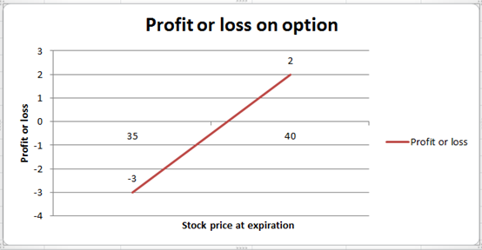
6) Spot Price=$100
3m Call option with Ex Price of $100 =$10
Stock pays no dividend
Require Put Premium
Risk free rate=10%
3 month interest=10*3/12=2.5%
Put Call Parity Theorem:
Call premium + Exercise price/(1+r)=Spot Price+ Put Premium
10+100/1.025=100+P
Solving we get P=7.56098
b) Now as we expect that within a period of 3 months there will be a break out in price of stock. if we expect that there would be a upside breakout than we can but the call option @ $10 and any price above 110 would give us profit. If we expect that there would be a downside break out than we can but the call option @ $7.56098 and any price below 92. 45 would give us profit. However when we are not sure about which side the break out would be then we can buy both call and put option in any combination depending on our price expectation.
Suppose we buy 1 call option and 1 put option then our total premium would be $17.56098 and any price below 82.45 or above 117.60 would give us a profit.
7)
Spot Price | Pay-Off from 1st Long Call | Pay-Off from 2nd Long Call | Pay-Off from Short Calls | Total Payoff
St<X1 | 0 | 0 | 0 | 0
X1<St<X2 | St-X1 | 0 | 0 | St-X1
X2<St<X3 | St-X1 | 0 | -2(St-X2) | X3-St
St>X3 | St-X1 | St-X3 | -2(St-X2) | 0

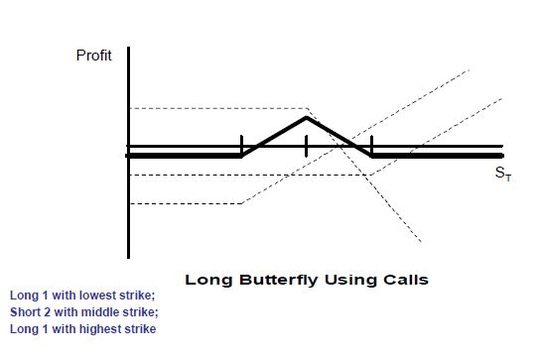
8)A call option is an option which gives the right but not the obligation to the option holder to purchase the assets or exercise the contract. Option is exercised at predetermined or at a specified price on or before the expiration date. A call option holder exercises his contract only when the market price of the underlying share is higher than the contract price. This is because; call option holder always want to purchase the shares at lower price. The investor will fetch profit which is equal to the differences between both the prices that are contract prices and market prices.

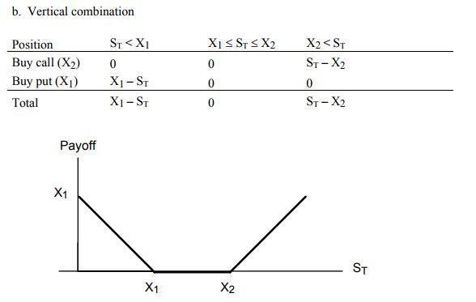

9) a)Exercise price of put option written = 90
Exercise price of put option bought with same expiration date = 95
Table of “value of the portfolio” is as follows:
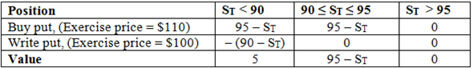
graph of the “Value table” is as follows:
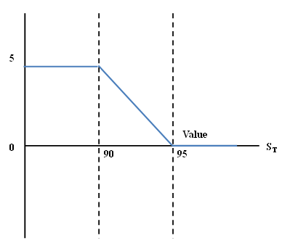
b) Table of “value of the portfolio” is as follows:
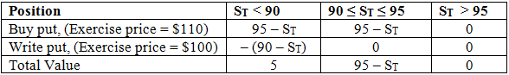
In this strategy, “Profit” is the difference of value and cost.
*The option with higher exercise price must cost more.
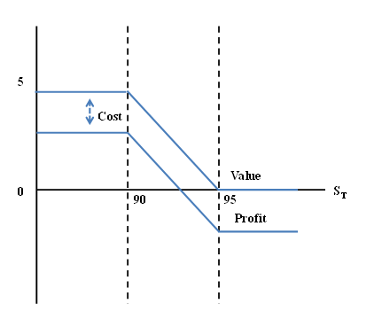
10) The payoff table shows a risk-less with time-T and stock value equal to $10.
Position
Buy stock
Short call | 0
Long put |  | 0
Total | 10 | 10
Now the risk free rate can be calculated using the following formula: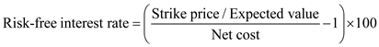
Substitute
Strike price as $10 and net cost as $9.5: 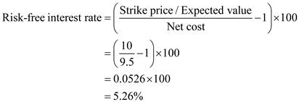
Thus, the risk-free interest rate is.

